Module-4 | Harmony in the Nature/Existence : (3 hours)
Understanding Harmony in the Nature, Interconnectedness, self-regulation and Mutual Fulfilment among the Four Orders of Nature, Realizing Existence as Co-existence at All Levels, The Holistic Perception of Harmony in Existence

So far, we elaborated on harmony in the individual, family and society. Now, we move to the next level, i.e. nature. Human order is a part of nature; hence, it is essential to understand the nature and the participation of human being in nature for a mutually fulfilling and sustainable way of living. After discussing nature, we will move on to understand the existence as a whole which is in the form of units (nature) submerged in space.

Understanding Harmony in Nature Nature as Collection of Units
Nature is the collection of all the units – the air, soil, water, plants, trees,
animals, birds, other humanbeings and even things that are at a distant from us like the sun, the moon, the other planets, etc.

Classification of Units into Four Orders
Although the units are innumerable, they can all be classified into just four orders:
- Physical order – this includes units like air, water, metal and so on.
- Bio order – this includes grass, plants, trees, etc.
- Animal order– this includes animals and birds.
- Human order– this has human being only.

Harmony among the Four Orders
There is mutual fulfilment among the first three orders in nature. The soil-plant interaction is an example of mutual fulfilment between the physical order and the bio order. Animals and birds (units of the animal order) depend on plants (units of the bio order) for their food. At the same time, animals and birds help to spread the seeds of plants from one place to the other. They protect plants from harmful insects and pests. Similarly, the units of physical order, like air and water, are essential for animals to survive. In turn, animals enrich the soil – their dung and their dead bodies act as very good manure which makes the soil fertile. This is amply visible in the forests. These three orders are enriching for the human being too. This we can see from our day to day life.

Now, is the human being fulfilling for the other three orders? This is a big question. Human being is not only unfulfilling for the other three orders, rather it is dominating and exploiting them, to the extent of global warming and climate change.

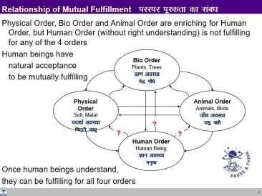

However, when we refer to our natural acceptance, we want to fulfil all the four orders. Ask yourself this question, “what is naturally acceptable to you – to enrich these four orders or to exploit them”? The answer is obvious – to enrich all the four orders. Once human beings understand the mutual fulfillment among the four orders, they can be fulfilling for all the orders.
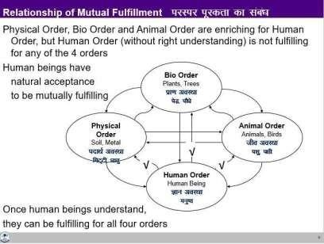

Interconnectedness, Self-regulation and Mutual Fulfilment among the Four Orders of Nature
With the above discussion, we can conclude that there is interconnectedness and mutual fulfilment among the four orders in nature. One can also see that there is self- regulation in nature. In a forest, the proportion of soil, plants and animals of various

species is self-regulated. It never happens that the lions eat up all the deer or the deer eat up all the grasses or that the plants grow to the extent that there is no space for deer or that there is lack of soil for new plants and so on. The forest does not need to be regulated by human being to be in harmony. With right understanding only, human being will also be self-organised, in harmony within and participate in the harmony in the larger order.

Abundance in Nature
Nature is organised in such a manner that the physical facility required for any order is available in abundance. The quantity of soil is far more than that of plants and trees. And both of these are available in far greater quantities as compared to the quantity of animals and birds. Human beings require all these three orders to survive, and the quantity of all these three orders together is far more than the quantity of human beings. By its very being, nature is organised in a manner where quantity of all four orders is in a sequence:
Physical order >> Bio order >> Animal order >> Human order. Therefore, the requirement of any order is already available in abundance.

Key Takeaways
Nature is the collection of units. It can be classified into four orders, (physical, bio, animal and human). There is a relationship of mutual fulfilment amongst these. It is already going on in the first three orders. Human being also has the natural acceptance for mutual fulfilment. All that we need to do is to understand it and live accordingly.

Realizing Existence as Co-existence at All Levels

In this lecture, we will explore into the harmony in existence.

Existence as Units in Space

Existence is whatever exists.
There are two types of basic realities in existence – one is space and the other is units. The units are inspace.

Understanding Units and Space
There are innumerable units in existence. There is air, water, soil, earth, sun, moon, plants, trees, animals, birds, human beings etc. These units are in space. The co- existence of the two is in the form of units submerged in space.

Units are Limited in Size; Space is Unlimited
We can observe units all around – they are limited in size. Coming to space, it is unlimited. It is spread all around. It is all-pervading. There is no limited size of space. It does not have any boundary.

Units are Activity, they are Active; Space is “No-Activity”
Every unit is an activity and it is active with other units. In itself, one or the other kind of activity is always taking place in the unit. Further, the unit is interacting with other units, i.e. it is active in relation to other units. When it comes to space, it is no- activity. There is activity only in the units.

Understanding Submergence
Units are in space – they are submerged in space. It means units are in space, they are inseparable from space. Where ever a unit is there, space is also there.

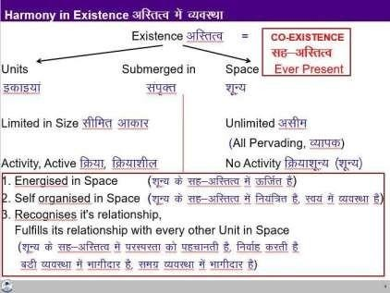

Units are Energised in Space
Being in co-existence with space, every unit is energised, right from the smallest atom to the largest planet.

Units are Self-organised in Space
Being in co-existence with space, every unit is self-organised. It is in a definite order. By being in a definite order, it exhibits a definite conduct – that is how one can identify or recognise and study thatunit.

- Units Recognise their Relationship and Fulfil it with Every Other Unit in Space Being in co-existence with space, every unit recognises its relationship with every other unit in space and fulfils that relationship.

Existence as Co-existence – Units Submerged in Space
Existence is co-existence. It is in the form of units submerged in space. In the light of above discussion on existence as co-existence, we can now visualise the overall picture of the whole existence.

Key Takeaways
Existence is co-existence, which is in the form of units submerged in space. Units are energised, theyare self-organised and they recognise their relationship with other units and participate with them in a mutually fulfilling manner (except for human beings without right understanding).

The Holistic Perception of Harmony in Existence

In the light of this discussion, we can now visualise the overall picture of the whole existence.

The Holistic Perception of Harmony in Existence
At the base of the whole existence is co-existence, which unfolds in terms of units submerged in space.
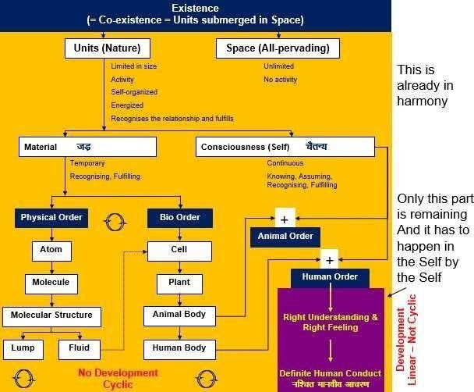

Units are limited in size; they are activity and are active. Space is unlimited, all- pervading and is no activity. Being submerged in space, units are energised, self- organised and recognise their relationship with every other unit in space and fulfil it.

Units are of two types – material units and consciousness units. Material units are temporary in time, while consciousness units (Self) are continuous. Material units recognise and fulfil their relationship with other units– their conduct is definite. Consciousness units recognise and fulfil their relationship on the basis of assuming without knowing or assuming based on knowing – the conduct of the human being is definite if it is operating on the basis of assuming based on knowing; and it is indefinite if it isoperating on the basis of assuming without knowing.
All material units are composed of other (simpler) material units. The smallest or fundamental stable material unit is the atom. An atom may combine with another atom to form a molecule. These molecules further combine to form molecular structure.

Molecular structures can exist either as lumps, or fluids. Fluids provide nurturing of cells and such cells combine to form plants, the animal body and the human body.

Coming to the domain of consciousness, there is just one type of unit which we have referred to as the Self. We can classify all the units in existence into four orders. Material units can be classified into two orders – physical order and bio order. The animal order is the co-existence of consciousness (Self) and the animal body (material). The human order is also the co-existence of consciousness (Self) and the human body (material).

Development in the Existential Sense
Now, we can see that everything is in co-existence. Everything that exists is basically the expression of this ever-present co-existence. It is expressing itself in the form of harmony and relationship. This unfolding is something which is happening and has to be completed through human being.

Whatever we do with the material world is cyclic. It will keep changing; keep going back to initial state, no matter what we do. In that sense, there is no development here. Only in the human order, there is a potential for development or transformation in the Self which is not cyclic. Development or permanent change is possible only in the domain of consciousness. It is in terms of

- developing right understanding (understanding co-existence) and right feeling (feeling of co- existence) in the Self. It means awakening to the activities of contemplation (of relationship, participation in the larger order), understanding (of self-organisation, harmony) and realisation (of co-existence), as discussed earlier, and
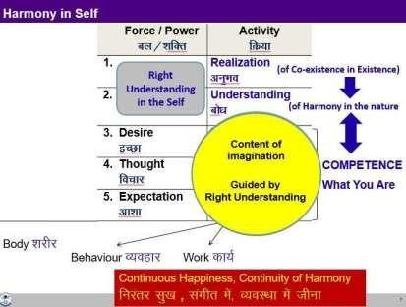

- living on the basis of right understanding and right feeling- part one is updating all our desires, thoughts and expectations in line with right understanding and right feeling; part two is the expression in the form of behaviour, work and participation in the larger order.

This development, this transformation in human being is facilitated by education- sanskar. There is every provision in existence for this development.

Sum Up

Now, we can sum up all that has been discussed in the workshop. We started by explaining the meaning of value. It was put as shown in the figure:
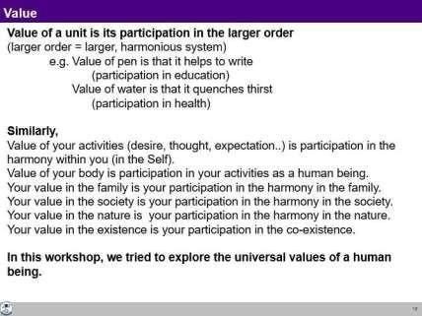
Then we went on to discuss the value at all the levels which is explained below.

Expression of Co-existence at Different Levels
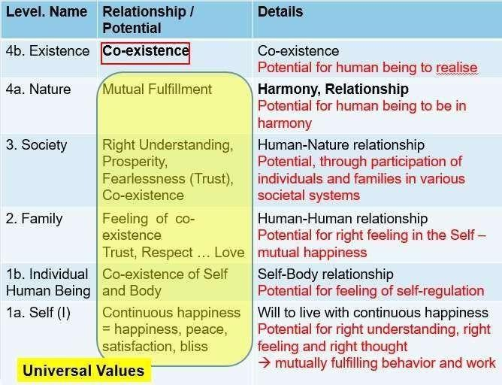

With this background, we can see that all that we discussed about harmony at the level of individual, family, society and nature are basically the systematic reflection (the expressions) of existence as co- existence. The same is shown in figure below. The whole discussion so far can be summed up in a simple chart given below. It can be expressed in one word – „Co-existence‟.

Natural Outcome of the Understanding
The completion point for human being (materialising universal human order) is also the completion point of the universal order in existence. In that sense, the universal human order and universal orderare synonymous. This is also the total expression of existence. It is the completion point of unfolding of the existence as co-existence.

Thus, My Participation (Value) in Existence is to Realize the Co-existence and Live in Co- existence.

Key Takeaways
Existence is co-existence, and the role of human being is to realise co-existence in the Self and live in co-existence in nature/existence, extending up to universal human order. In this way, the unfolding of the co-existence will be completed through human being – resulting into universal order.

Program of Action
With the discussion so far, now we can work out the program of action at the individual level and at the level of society.
At the level of individual, what is expected is to understand harmony and live in harmony. This is something that has been initiated in the workshop.
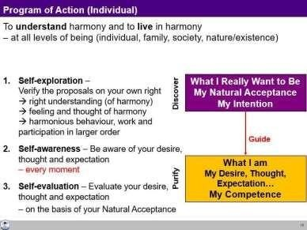
In the process of understanding, three things are required as mentioned above:
- Self-exploration: Verifying the proposals on our own right and living accordingly
- Self-awareness: Being aware of one’s desires, thoughts and expectations every moment
- Self-evaluation- Evaluating one’s competence vis-à-vis the natural acceptance every moment.
These three things will help one transform from the present level of competence to the level of completeness of right understanding and right living in continuity. The time taken for this may vary from person to person, but the process is definite.
At the level of society, what is expected is shown in the figure below.

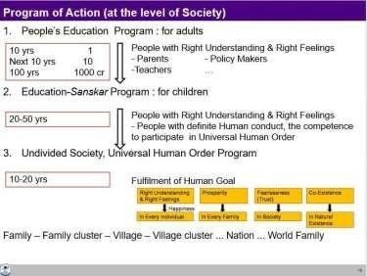

One kind of program can be the people’s education program meant for adults. People with a definite level of competence can help grown-ups from different backgrounds to self-explore and develop their competence. Going this way, on an average, if one person takes 10 years to develop the commitment to understand and live accordingly in completeness, and develops 10 more such people in the next 10 years, a population of 1000 crores can be developed in 100 years. But if the program of education-sanskar is made value based, it will take a shorter time, say up to 50 years for the world, as the program for right understanding will become a definite component of the system of society. And if there is a program for undivided society and universal human order including all the dimensions of the society, it will take even shorter time. This can be a vision while making the policies at the level of society.

